SNES Gamepad Adapter for Commodore PET Rev.0
Testing

Test Setup
- PET SNES Gamepad Adapter Rev. 0
- Diagnostic Cassette Port Dongle & 6-way ribbon cable
- A SNES Gamepad (non USB version)
- Commodore CBM3016
- Commodore CBM8032
- Commodore C64
- Software “SNES TEST.BAS.PRG” from zimmers.net (in snes_adapter.zip, see module description
- Software “PETROBOTS12.D64” (PETSCII Robots paid version from The 8bit-Guy)
The PET SNES Gamepad Adapter was connected to the user port of the respective computer. The Gamepad was connected to the device under test.
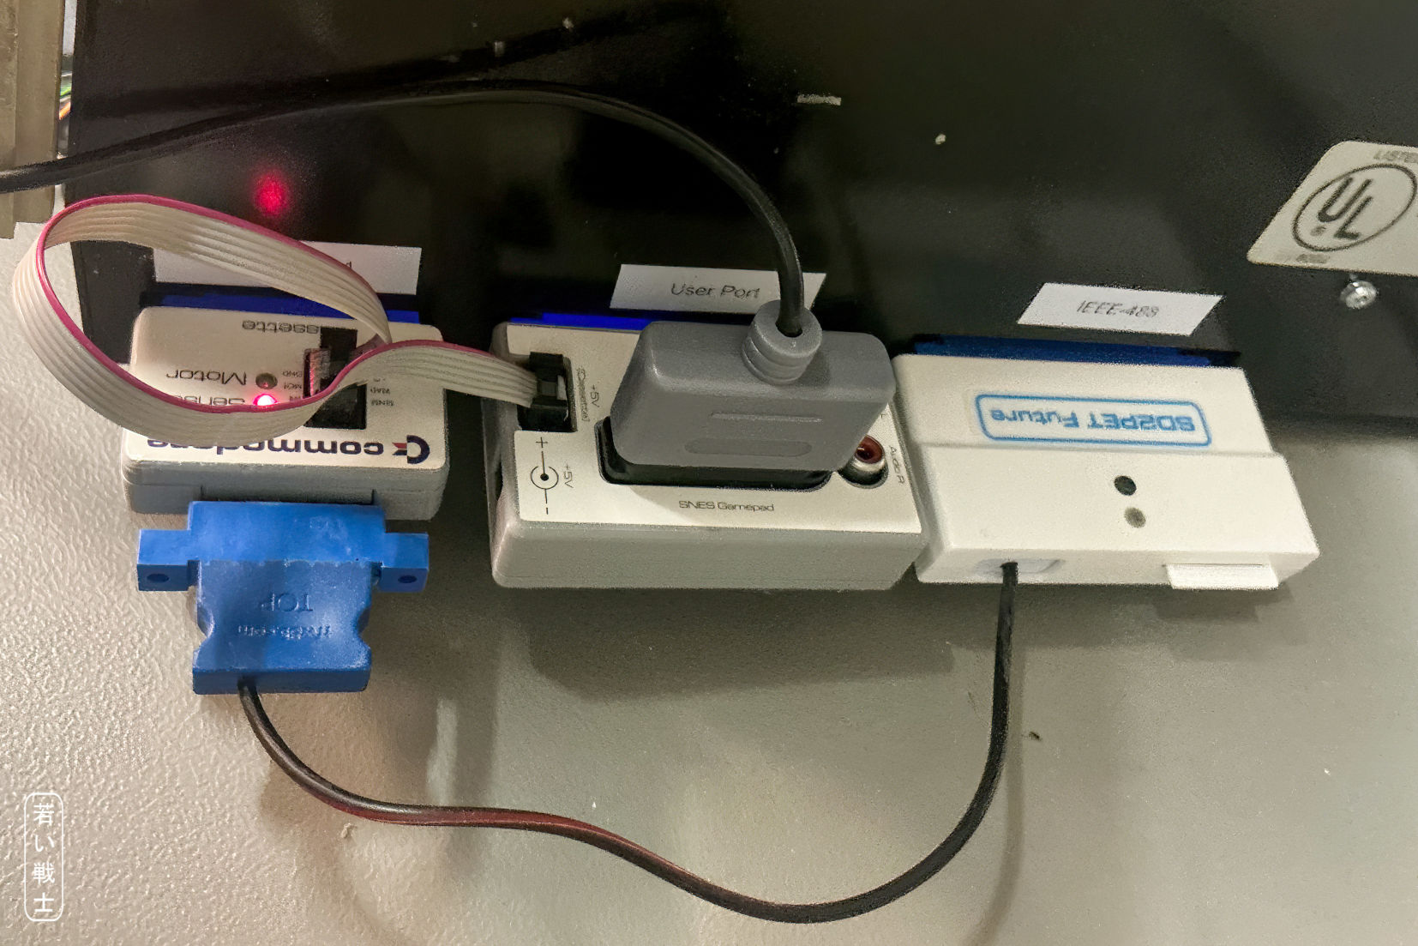
Figure 1: The PET SNES Gamepad Adapter, powered by cassette port and an SD2PET Future with the required software

Test Execution

Testing The Readout of The Gamepad
The computer is the CBM3016, the software is SNES TEST.BAS.PRG. The program was stored on the SD2PET SD card. Loaded and started.
Every button was pressed on the gamepad. The software has display each of that properly.
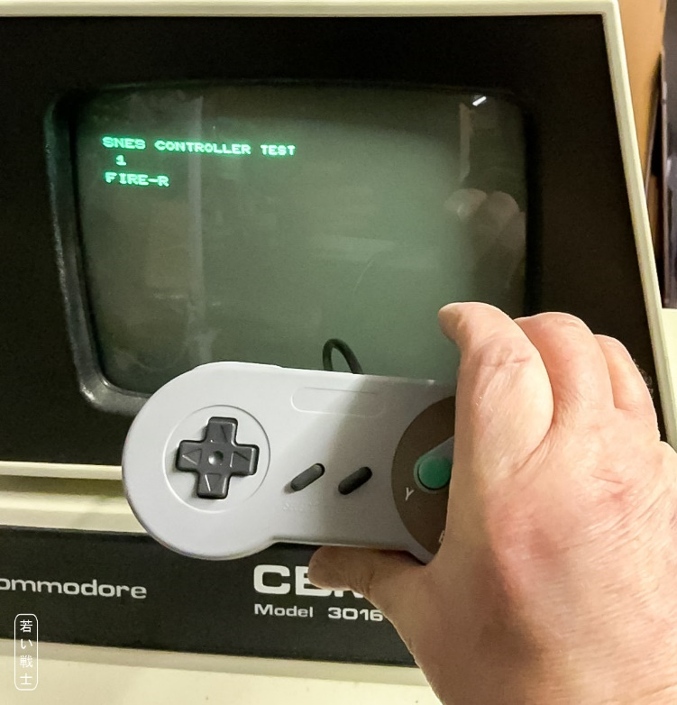
Figure 2: SNEST TEST.BAS.PRG on CBM3016
The same test was conducted on the CBM8032. Again, every button was displayed properly.
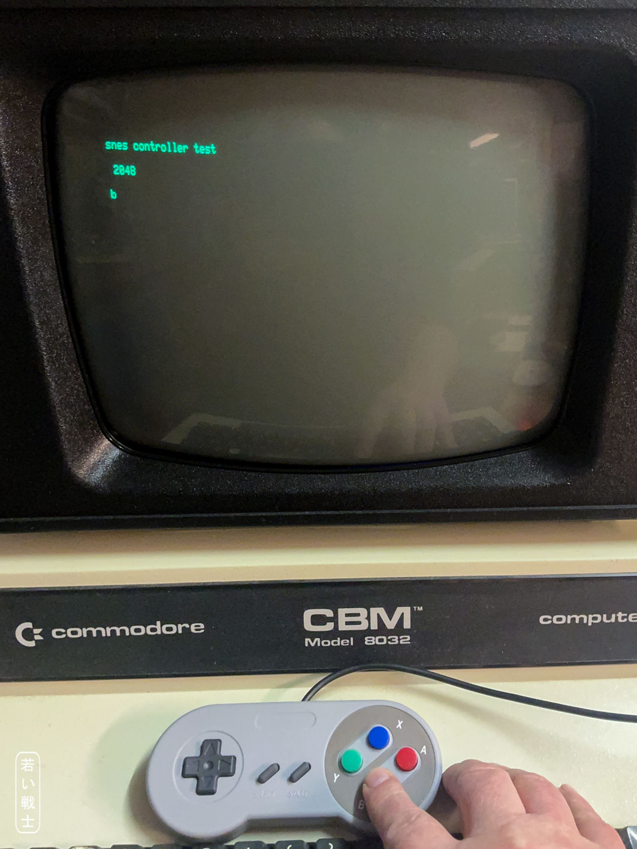
Figure 3: SNEST TEST.BAS.PRG on CBM8032

PETSCII Robots on CBM8032
Due to memory size, the PETSCII Robots software was run on the CBM8032, which had to be set to 40 columns previously.
As a game controller, the SNES Gamepad was selected.
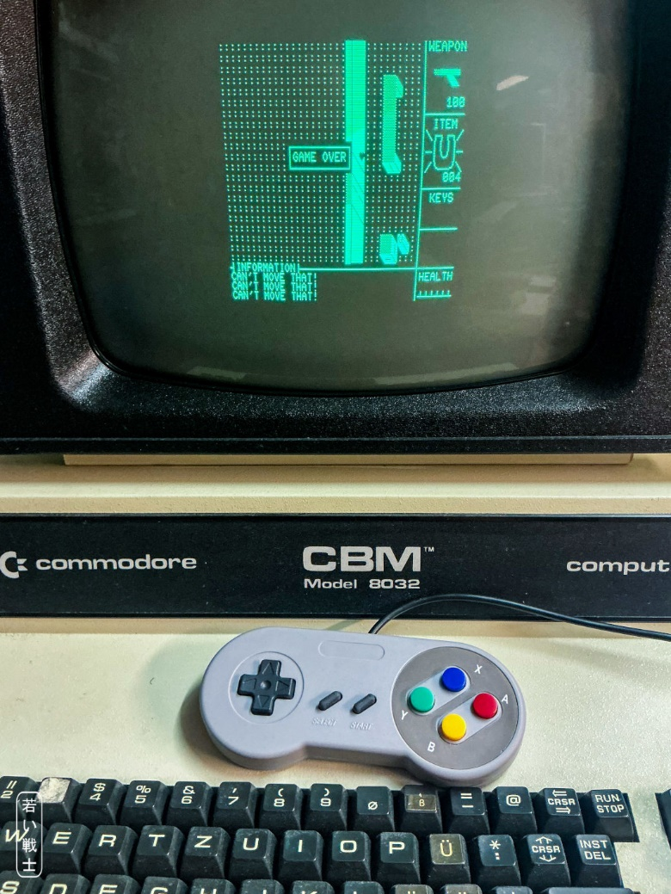
Figure 4: PETSCII Robots on the CBM8032
The software reacted properly to the SNES Gamepad.

PETSCII Robots on C64
The Gamepad was connected to the C64 via the device under test. A cassette dongle was required to power the gamepad. The software was run from the disk image “C64Robots v1.3.d64”, which was part of the PETSCII Robots purchase.
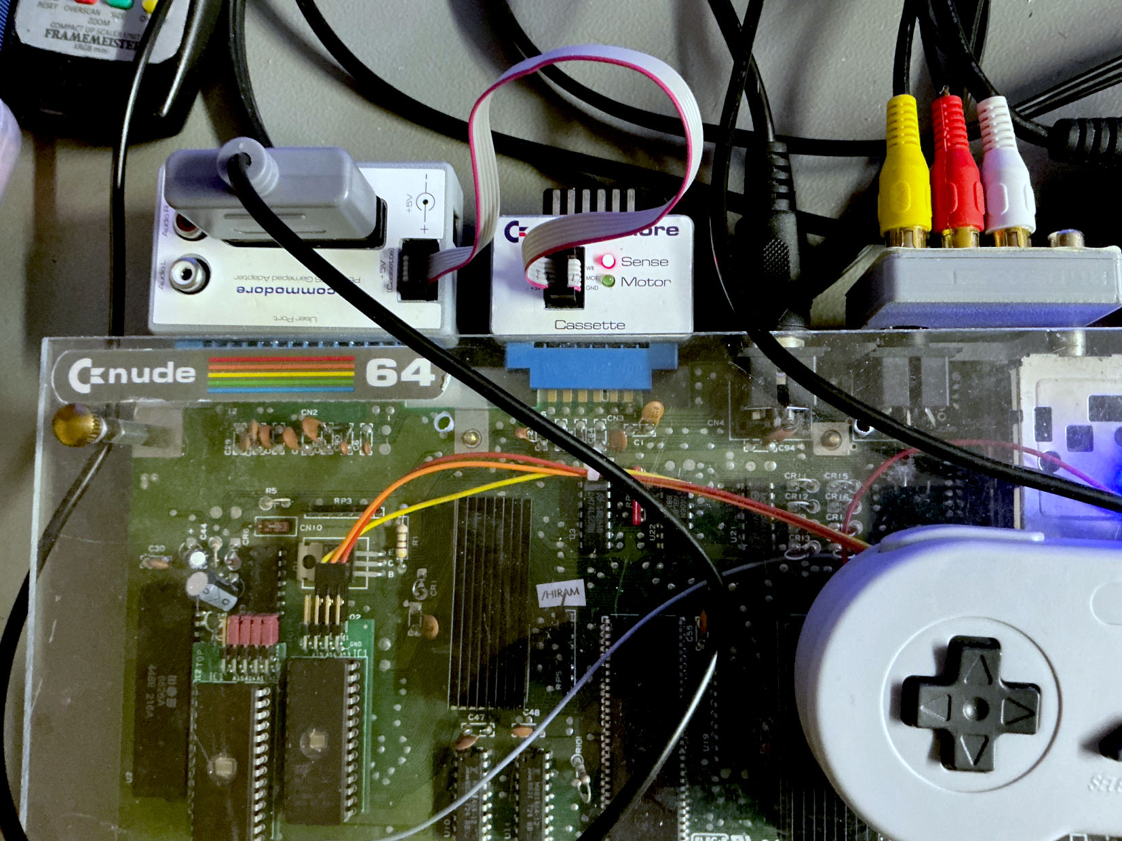
Figure 5: The PET SNES Gamepad Adapter Rev. 0 connected to the C64
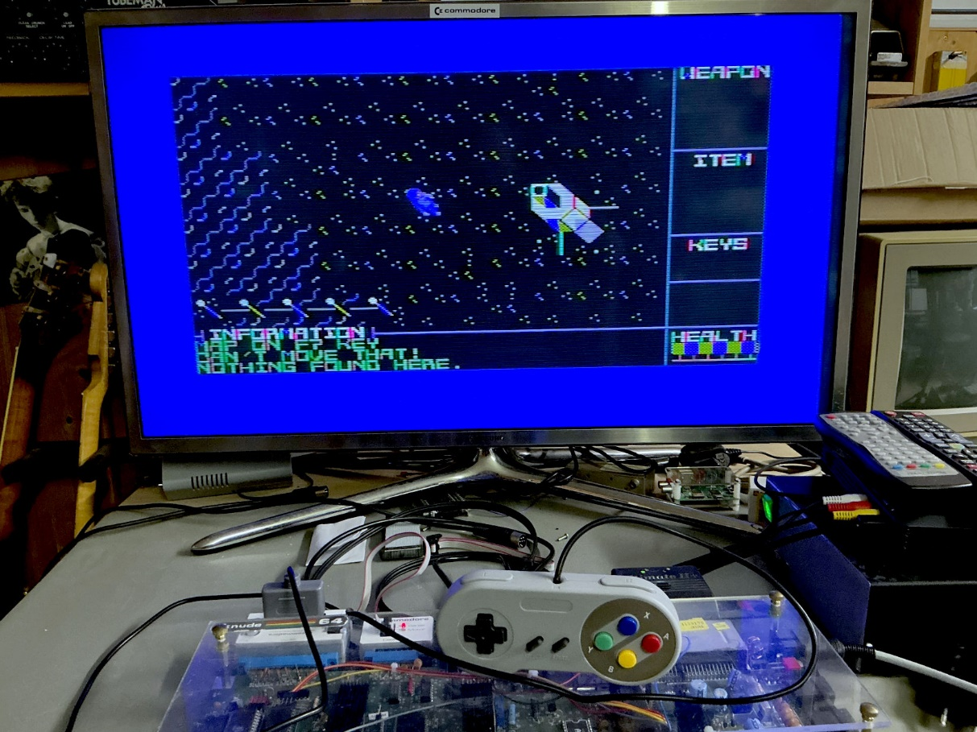
Figure 6: PETSCII Robots on the C64
The software reacted properly to the SNES Gamepad.

Conclusion
The PET SNES Gamepad Adapter Rev. 0 is working properly.

